Spatial Mapping of GBV Services and Priority Access Gaps in Balaka District

Purpose and Scope
Mchinji District remains a significant GBV-burden district where survivors face persistent spatial and economic barriers in accessing health, police, psychosocial and justice services, despite a moderate overall service presence. While key Traditional Authorities (TAs) such as Mkanda and Mduwa host most mapped GBV service points, survivors from peripheral settlements and border-adjacent villages experience longer travel times, higher transport costs, and reduced access to specialised services, particularly courts, One Stop Centres (OSCs) and legal aid.
Spatial analysis indicates that GBV services in Mchinji are strongly corridor-based, concentrated along the main transport axis and secondary feeder roads. Average travel times are relatively short in well-connected zones, but increase substantially for off-corridor and remote communities, particularly during the rainy season when road conditions deteriorate. This policy brief provides a synthesis of GIS spatial analysis, TA-level population density mapping and facility-level referral and resolution data and actionable recommendations for improving survivor-centred access and reducing spatial inequity in Mchinji District.

Spatial Profile of GBV Services in Mchinji
Mchinji District displays mixed population density patterns, with moderately dense settlement clusters along the central transport corridor and lower-density populations in peripheral and border areas:
- Mchinji had 21 mapped GBV service points, distributed primarily across TA Mkanda (14 facilities) and TA Mduwa (7 facilities), positioning these two TAs as the district’s principal GBV service hubs.
- TA Mkanda hosts the majority of services, including Community Victim Units (CVUs), health clinics, Police Victim Support Units (PVSUs), women’s forums and other community structures. These facilities are largely aligned with the main road and secondary routes, offering comparatively good access for central settlements while leaving more remote villages underserved.
- TA Mduwa contains fewer service points, but benefits from relatively favourable road connectivity. Travel-time modelling shows average journeys of approximately 20–30 minutes for many communities; however, settlements located further from feeder roads face higher travel-time variability and increased costs during the rainy season.
- Population density in both TAs falls largely within the 100–161 persons/km² band, reinforcing demand for accessible, high-volume frontline services. Dense settlement pockets near the corridor correlate with higher CVU and clinic caseloads, while sparsely populated outer zones show lower recorded referrals, suggesting access-related under-reporting rather than lower incidence.
- Travel-time surfaces indicate average travel times of 21–35 minutes to the nearest GBV service provider in Mkanda and Mduwa, but off-corridor settlements, particularly near border areas or along tertiary roads experience significantly longer journeys that exceed mapped averages.
- Transport costs for survivors generally range between MWK 5,000 and MWK 8,000 per trip, with costs increasing sharply for repeat visits involving health follow-up, police reporting and court attendance, creating a substantial burden for low-income households.
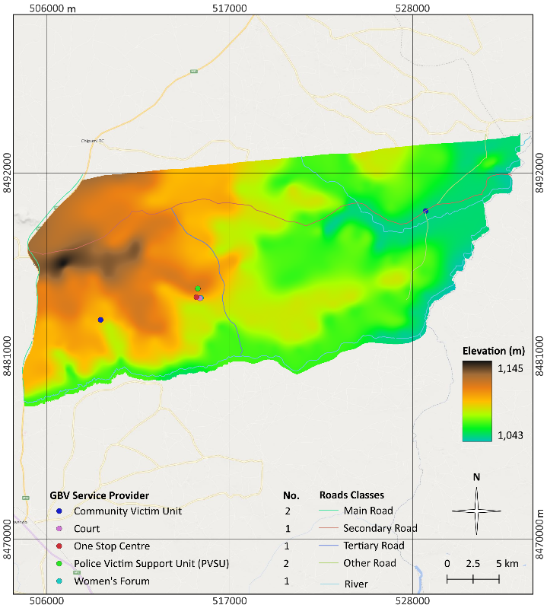
Figure 1: Distribution of GBV Service Providers in TA Mduwa
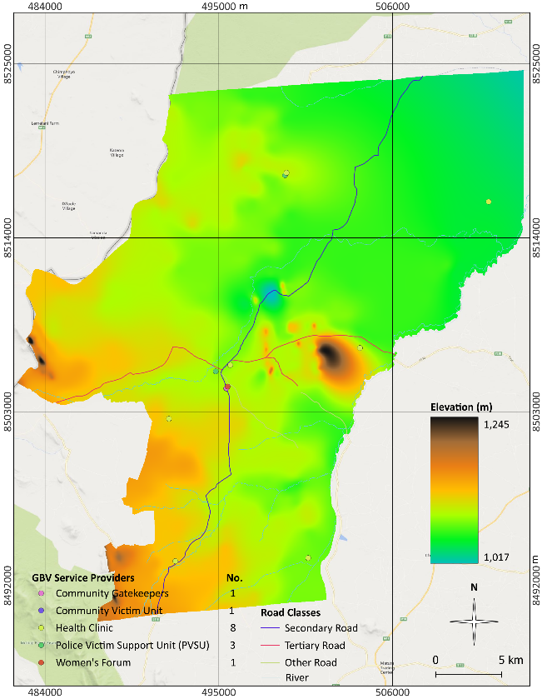
Figure 2: Distribution of GBV Service Providers in TA Mkanda
Implication:
Although Mchinji appears moderately well served at district level, effective access to GBV services is uneven and corridor-biased. Survivors living outside the main transport axis face longer travel times, higher costs and weaker follow-through along referral pathways, particularly to justice-sector services.

Key Accessibility Gaps and Systems Challenges
The combined spatial, referral and case-management data points to a GBV system that is present and active across the two TAs, but structurally uneven, costly to access, and weakest where survivors need it most at the level of justice and long-term protection. Five interlinked systems challenges stand out.
- Spatial inequity across and within TAs was pronounced, with GBV services concentrated in a small number of service providers while large peripheral areas remained underserved, resulting in access-driven under-reporting rather than true differences in GBV incidence.
- Long travel distances (20–34 km), extended travel times (21–35 minutes), and high transport costs (MWK 5,000–8,000 per trip) acted as structural filters that disproportionately excluded poor, rural and remote survivors particularly in far-remote locations from accessing GBV services.
- While counselling and basic support were widely available, specialised GBV services including forensic care, legal aid and OSCs were sparse and district-based, and the justice system remained the weakest link, with magistrate courts resolving only 25% of cases and lacking criminal jurisdiction at 2nd/3rd grade magistrate level.
- Referral chains exhibited a steep attrition curve, where most cases originated and were resolved at community, health and police levels, but survivor engagement dropped sharply as cases moved toward the justice system due to distance, repeated travel requirements, costs and weak feedback loops.
- GBV information systems were fragmented across paper and digital tools, lacked unique case identifiers, applied inconsistent definitions of “case” and “resolved,” and suffered from missing disaggregation, resulting in unreliable totals, untraceable survivor pathways and limited capacity for accountability or learning.
- Survivor outcomes were shaped by interconnected location constraints determining physical access, income determining ability to follow through, service type determining case trajectory, and weak data systems obscuring gaps, highlighting the need for simultaneous action on spatial equity, affordability, service depth, referral linkages and data integration.
- Even before considering communication, attitudinal or financial barriers, around one in three GBV service points explicitly reported that their physical infrastructure is not accessible to persons with disabilities, and only about half reported meeting basic accessibility standards (e.g. ramps, wide entrances, accessible toilets).

Policy Recommendations
Policy Option 1: Support Circuit or Mobile Court Sessions, Mobile Legal Clinics
Support circuit or mobile court sessions in high-burden, distant TAs to reduce the number of long, costly trips required for survivors and witnesses.
Strengthen police–prosecution–court communication and case tracking so that criminal GBV matters referred out of TAs are systematically followed through at district level.
This option directly addresses spatial exclusion and provides timely services closer to survivors’ homes.
Advantages: Immediate reduction in travel burdens; improved early reporting; higher likelihood of referral completion.
Disadvantages: Requires reliable vehicles, fuel, and scheduling; limited reach during heavy rains.
Feasibility & Cost: Moderate, with strong donor feasibility.
Equity Impacts: High prioritises remote, low-income and terrain-isolated households.
Policy Option 2: Establish a Sustainable Survivor Support Fund (SSF) and Accompaniment Mechanism
Given the long and costly journeys faced by survivors from peripheral and border-adjacent villages in Mkanda and Mduwa, Mchinji District should operationalise a sustainable Survivor Support Fund (SSF) to cover essential transport, food and accompaniment during GBV referrals. The SSF would combine district-based allocations, MICGBV support, partnerships with local transport unions and revenues from TA-level IGAs to ensure continuity beyond donor cycles. A voucher and digital-tracking system would maintain accountability and cost control. By reducing financial attrition and enabling survivors to attend multiple appointments particularly court sessions at district headquarters the SSF would directly strengthen case progression and access to justice.
Advantages: Reduces financial barriers; increases court case follow-through.
Equity: High, especially for poorest households and those living furthest from the road network. Survivors from remote / hard-to-reach TAs (flood-isolated parts), survivors with disability, minors, and those at high lethality risk and those below a simple poverty threshold (screened via local criteria)
Feasibility: High with partner support.
Policy Option 3: Co-design upgrading of Corridor-Based High-Volume Facilities
Facilities along the main Mzimba transport corridor manage large caseloads. Strengthening their counselling spaces, privacy infrastructure, and medico-legal documentation capacity would reduce unnecessary referrals and improve service quality.
Co-design upgrades with Organisations of Persons with Disabilities (OPDs) at district level to test access routes, advise on practical modifications, and validate whether reported “Yes” responses on accessibility reflect real, user-experienced access, not just provider perception.
Set minimum accessibility standards or a basic package for GBV service points (ramp or gently sloped entrance, firm pathways, accessible latrine, clear signage) that all GBV service providers should progressively meet.
Advantages: Builds on existing strong hubs; improves efficiency and quality.
Feasibility: High.
Equity: Benefits densely populated areas.
Policy Option 4: Institutionalising GIS for Planning and Resource Allocation
Annual GIS-based audits of service coverage, population density, travel times and TA-level gaps would inform district GBV planning and budgeting.
Advantages: Enhances evidence-based prioritisation; prevents spatial neglect.
Feasibility: High with partner support.

Methodology
Policy options were derived from spatial accessibility modelling (travel time surfaces, road networks, elevation) and TA-level population density analysis. Facility-level referral and resolution data (2022–2025) were triangulated with key informant consultations with police, health workers, CVUs, and district officers. Evidence quality was assessed through data completeness checks and plausibility reviews.

Further Important Considerations
Because of data-quality limitations (inconsistent definitions, outliers, missing values), the figures in this study were best treated as operational estimates rather than precise surveillance statistics. This implied that the rollout of recommendations should be coupled with an explicit monitoring and learning agenda: annual updates to GIS layers and dashboards, routine data-quality checks, and periodic sense-making sessions at district level to review patterns (e.g. travel times, referral completion, court progression) and adjust interventions accordingly. Over time, this iterative use of data could be more transformative than any single investment in infrastructure or training.

Acknowledgements
Prepared in collaboration with the Mchinji District Gender Office, Social Welfare Office, Health Office, MICGBV partners, and frontline GBV service providers.

